**Lab Cycle 2**

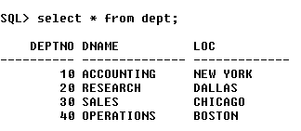

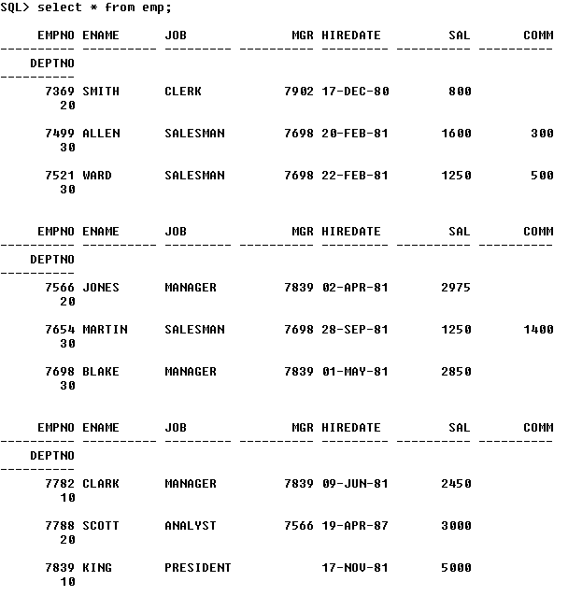

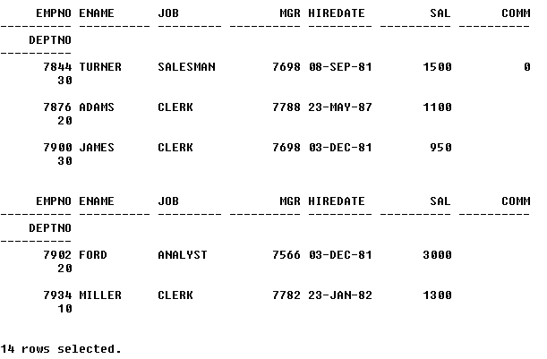

**Write Select statements for the following queries using SQL single row functions:**

1. Display the department names in the lower case but the initial must be in uppercase.

**SQL> select initcap(dname) as "Dept. Name" from dept;**

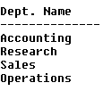

2. Determine the ‘ename’, ‘job’, ‘sal’ rename the title as Job-sal the output must be Job-Sal as SMITH [CLERK] RS.2000.

**SQL> select ename || ' [' || job || '] ' || 'Rs.' || sal as "Job-Sal" from emp;**

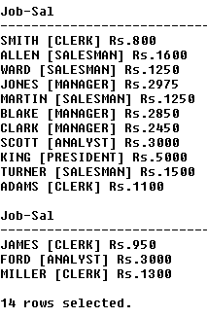

3. For each department, Count the number of times S occurs in department names.

**SQL>**

4. Write a query to display the department name which does not contain any employees.

**SQL>**

5. Write a query to display all employee details where employee was joined in year date wise 1980 and 1990 and 2nd week of every month.

**SQL>**

6. Write an SQL statement to convert the current date to new date picture ex: MONDAY 10th June 2005 10:30.00 PM.

**SQL>**

7. Write a query to display all employee details who joined last Wednesday of a month and experience should be greater than 20 months.

**SQL>**

8. Write a query to calculate the service of employees rounded to years.

**SQL>**

9. Write a query that will display a list of employees and their salary and the comments as follows:

a. If the salary is more than 1500 then display “above target”.

**SQL>**

b. If the salary is equal to 1500 then display “on the target”.

**SQL>**

c. If the salary is less than 1500 then display “below the target”.

**SQL>**

10. Display all employee names, employee number, department names &amp; salary grades for all employees who are working in department 30.

**SQL>**

11. Display the time of day.

**SQL>**

12. Find all employees who earn a salary greater than the average salary of their departments.

**SQL>**

13. Write a query to find the name of the manager and number of sub-ordinates.

**SQL>**

14. Write a query to find out the manager having Maximum number of sub-ordinates.

**SQL>**

15. Write a query to find out the top three earners.

**SQL>**

16. Write a query to find out the employees who have joined before their managers.

**SQL>**

17. Write a query to find out the year, where most people join in the company displays the year and No. of Employees.

**SQL>**

18. Write a query which will return the DAY of the week.(i.e. MONDAY), for any date entered in the format: DD.MM.YY.

**SQL>**